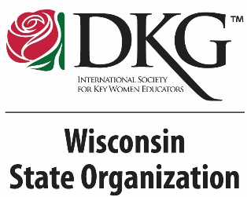
The Delta Kappa Gamma Society International
WISCONSIN STATE ORGANIZATION
Rules Committee ~ 2023-2025

The Wisconsin State Organization Rules Committee is reviewing the Wisconsin State Organization Standing Rules, Amended 2023 in preparation for the 2024 WSO State Conference next year. Proposed amendments to the STANDING RULES may be submitted to the Rules Committee by a member or group of members, a chapter, or a committee by October 1, 2023. You will find the Amendment Proposal Form on the state website.

The procedure to submit an amendment to the standing rules is clearly specified.
- Review the Wisconsin State Organization Standing Rules, amended 2023 found on the Wisconsin State Organization website.

- If you wish to submit a revision to the Standing Rules, prepare the Amendment Proposal Form (May 2023) available for you to download as a fillable form on the Wisconsin State Organization website.

- Be certain to include the rationale for the proposed change, including a brief explanation of why you feel the change is warranted.

- Estimate the financial impact, if any, of the proposal if it is approved.

- Sign the form and submit it before October 1, 2023 to Leslie Riese Bakkum, 2023-2025 WSO Rules Chair. Contact information:
Leslie Riese Bakkum, Theta chapter
S1669 Vang Road, Westby WI 54667
Email: clbakkum@gmail.com
cell: 608.780.1228

The WSO Rules committee will review your proposals and compile them for publication on the Wisconsin State Organization website and in the February 2024 Wisconsin State News. Thank you for your interest in the guiding documents of our state organization.

Please contact me with any questions. I look forward to hearing from you!

Leslie Riese Bakkum, Theta
2023-2025 WSO Rules Chair

